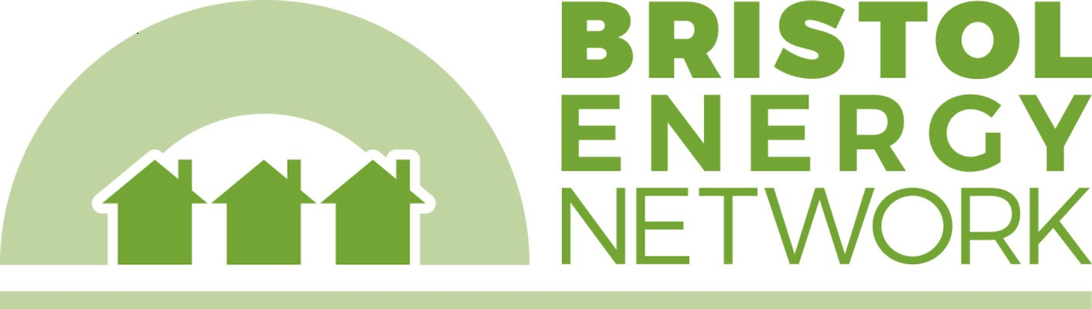

Bristol Emergency Winter Fuel Fund: referral form for Lockleaze Neighbourhood Trust
For residents of North East Bristol. If the citizen you are supporting is in another part of the city, please select a different organisation from the Bristol Energy Network website https://bristolenergynetwork.org/bristol-emergency-winter-fuel-fund/

Please complete all sections and save in a secure filing system in line with localised agreed GDPR procedures

Citizens details:
Full Name:
Full Address including postcode:
Email Address:
Phone Number:

Household energy details (optional):
Type of energy contract: | Prepayment Direct debit Credit (pay on receipt of bill)
Type of heating | Gas Electric storage heaters Solid fuel Other
Date last switched supplier?
Tenure | Private rented Social housing Owner-occupied
Issues in building | Double glazing Draughts Mould Open chimneys
Type of lightbulbs used | fluorescent LED traditional
No of bedrooms

Household:
No. of adults: |  | No. of children:
No. of OAPs: |  | No. of people with disabilities:

Nature of crisis:
Benefit changes or delays: |  | Debt: |  | Low income:
Wages changes or delays: |  | Homelessness: |  | Unemployment:
Child holiday meals: |  | Sickness: |  | Domestic violence:
Corona virus: |  | Other (please state below):
Please give a brief description of the crisis:

Name of Referral Partner Organisation:
Amount requested (£):
Bank details - Account name:
Account No:
Sort Code:
Award referred by: |  | Date:
Signature:

Bank details will only be used to make a payment to the household and will not be shared beyond distribution partner. Other details including contact information and household energy details will be shared with partner organisations to provide further support.

Please email this form securely to: admin@lockleazent.co.uk
You can send a secure email with a password from most email clients. This is to protect the bank details of people who are being referred for support.

FOR DISTRIBUTION PARTNER OFFICE USE:
Date received: |  | Award made? Y/N
Amount (£): |  | Date paid:

If you have any concerns or questions about this fund or how it is being distributed, please contact coordinator@bristolenergynetwork.org

