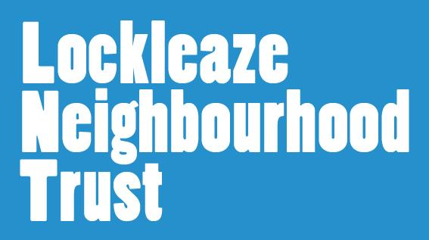
Volunteer Application Form

We welcome applications from people from all sections of the community, from diverse backgrounds
and who bring a variety of life experiences and skills to Lockleaze Neighbourhood Trust and our volunteer
roles.

Name | hf
Email address
Phone number
Address

Please indicate which areas/roles you are interested in (tick all that apply)

Event set up/set down |  |  |  |  | Group or Club support
Leaflet Distribution |  |  |  |  | Specialist skill to offer e.g finance, gardening
One off community events |  |  |  |  | Other (please detail below)
Details:
Please indicate what type of volunteer role you’re interested in and your availability (tick all that apply)
One off events |  |  |  |  | Regular weekly commitment
Adhoc as and when needed |  |  |  |  | Other (please detail below)
Details:
Why are you interested in volunteering with LNT at this time? (tick all that apply)
To meet new people |  |  |  | Gain new skills and knowledge
To progress in my career |  |  |  | To support my community
To be part of a team |  |  |  | Gain confidence
Other (please detail)
How did you hear about volunteering with LNT?
Word of mouth |  |  |  | LNT website
Twitter/Facebook |  |  |  | Other
Please tell us a little about your education, recent volunteering or work history
What skills can you bring to LNT? (This could be from previous work, volunteering or life experience. Please include any qualifications or training that might be useful e.g first aid training or DBS).
Do you have any access requirements or health conditions you’d like to tell us about here, or discuss in person?
References
Please provide details of people who could give you a reference.
These should be by a past ‘employer’(voluntary or paid) or educational referee.
Name |  |  |  | Name
E-mail |  |  |  | E-mail
Address |  |  |  | Address
Phone |  |  |  | Phone
Relationship to you |  |  |  | Relationship to you
Please return this completed form to ruth@lockleazent.co.uk or drop into The Hub, Fedden Buildings, Gainsborough Square, Lockleaze BS7 9FB.
What next? Many thanks for your interest in volunteering with us here at Lockleaze Neighbourhood Trust. Once we have received your application we will contact you to discuss it, and see whether we have any suitable opportunities that match your application.

Criminal Convictions Declaration

Please declare the date and details of any convictions that you may have been charged with:
Declaration
I certify that, to the best of my knowledge, all information contained in this form is true and correct. I realise that false information or omissions may lead to dismissal.

Signature…………………………………………………………………………………………………..

Date………………………………………………………………………………………………………….

Note: The information given is this form will be treated in the strictest confidence.

