Our Lockleaze Community Forum September 2021
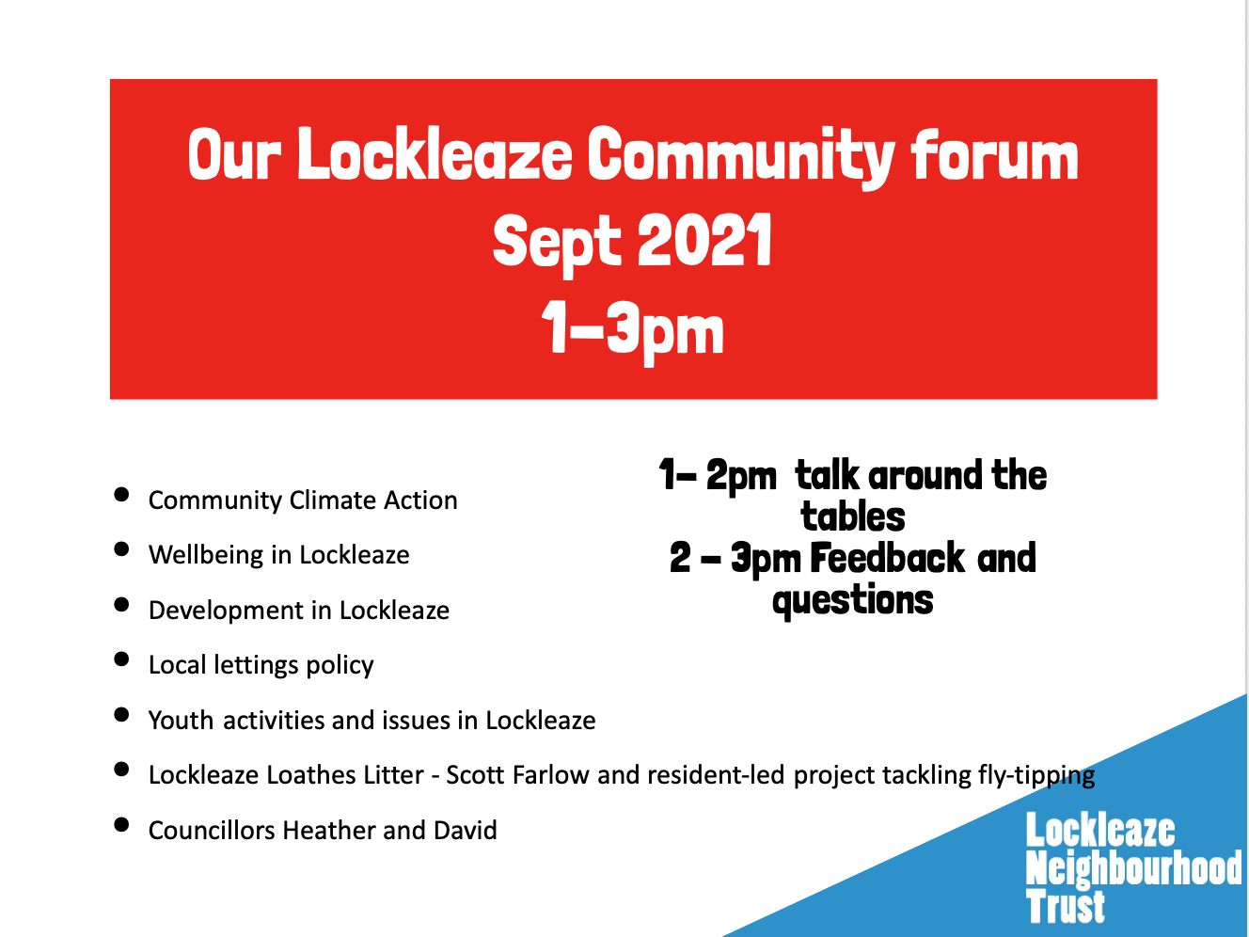 | Lockleaze Neighbourhood Trust facilitates community forums at least twice a year as a chance for  - Residents to get together and talk about issues that matter to them  - Support collective action on issues that matter to residents  - Hear about major developments and updates in tahe area  - Talk to local Councillors  - Invite police, developers and other organisations active in Lockleaze to update on what they are doing  Everyone is welcome to attend the events and we make them family friendly with crafts and games so they are accessible to families. The format we have found works is the first hour we call ‘talk around the tables’ where people chat on a 1-2-1 or in small groups and the second hour is feedback and questions. This allows those not willing to ask questions in a large group a chance to have their say and connect and avoids discussion being dominated by one individual to the exclusion of everyone else.  Below is a summary from the table discussions and feedback.
Jonathan Ford introduced himself, working as Wellbeing Navigator in Lockleaze. He talked about the impact of lockdown on wellbeing which had made many of us feel a bit wobbly. He spoke with people about using the blob tree to discuss how we were feeling, shared the draft wellbeing passport for people to try and give feedback. New in post his immediate task was pulling together a directory of all the existing groups that support wellbeing (using the five ways to wellbeing) that he is speaking with existing groups about wellbeing support and has been talking to residents about setting up friendly walking groups, or mindful walks (not as fast as the ramblers!) and also a drop-in cafe.
For more information contact Jonathan at wellbeing@lockleazent.co.uk 0117 9141129 Tues- Thurs

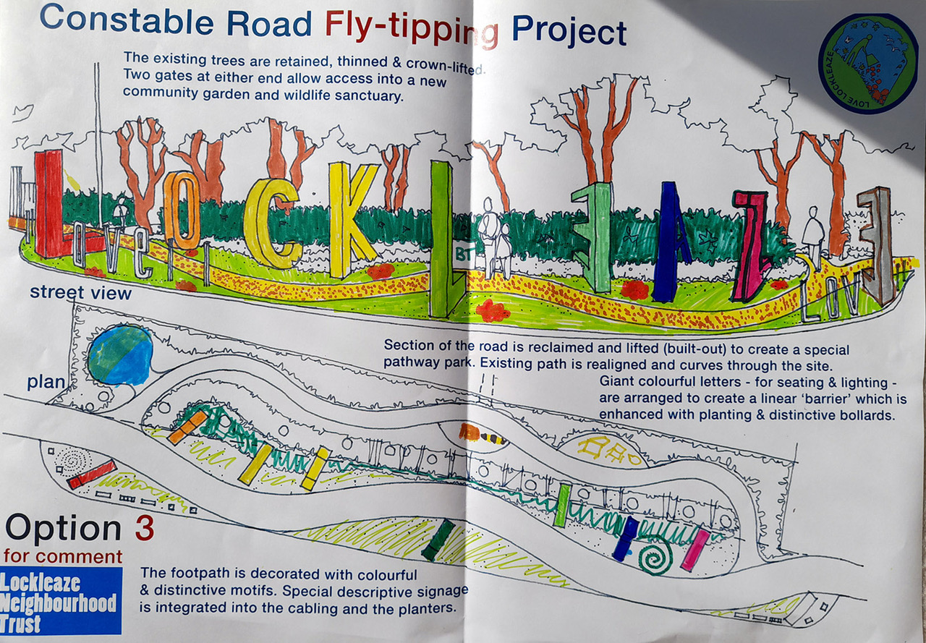 | Lockleaze Loathes Litter - Waste Warriors - Leazers don’t Litter  Artist Scott Farlow, has been working with residents, Lockleaze Neighbourhood Trust, Police and local businesses to consider what creative ways we could use to tackle fly-tipping in Lockleaze which is an eye-sore, costs money and brings down the reputation of Lockleaze. There has been a particular focus on Constable Road fly-tipping by the railway embankment and through several litter picking and creative workshop sessions Scott has worked with residents to design three draft proposals to turn waste ground into love ground. These were sneak previewed at the forum and will be discussed with the group next week at the community litter pick. Resident mentioned Ireland’s Tidy Towns initiative which had big community involvement - maybe something similar. Scott agreed this was more than just Constable Road and residents had talked about a campaign element too, inspired by Leithers don’t Litter  To join a litter pick or get more involved contact Maria@lockleazent.co.uk
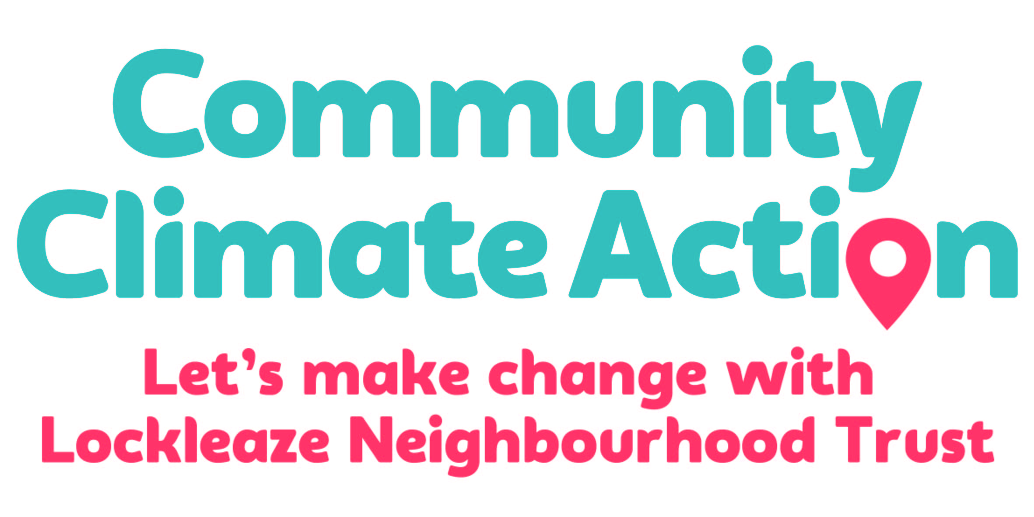 | Community Climate Action project working with residents and local organisations to come up with an action plan to get Lockleaze to zero carbon. Festival of solutions underway exploring alternatives for renewable energy, retrofit and housing measures to reduce heat loss and support climate resilience, looking at food systems to support local production, eliminate waste and reduce packaging exploring sustainable transport, as well as make-do-and-mend sessions particular with textiles to reduce consumption. Lots of ideas including green Christmas, supporting wildlife in gardens, community clothes swap coming up, interest in a community toy swap - maybe managed via Boing?
Youth and Play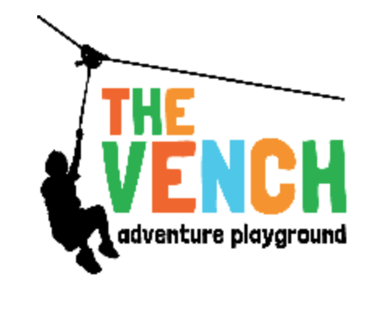 | Discussed increased issues and concerns with young people. Higher number of young people referred to Safer Options team but not enough staff/programmes to support them. Concerns about drug and knife crime. Concern that current provision is limited in numbers re: Covid, already over subscribed, will only increase with new developments. Concerns about gap in provision for 5-7 year olds (0-5 well served with Vench, Boing, Children centre - from 8 can go to Vench but 5-7 gap). Concerns about holiday provision. Youth and Play network of organisations working together on options.  For more information contact Amy Walshamy.walsh@groundwork.org.uk
 | Steph is a volunteer from the Old Library who has been volunteering there to make it more inviting and colourful, has painted the fence rainbow colours and led a craft activity stone painting today, the stones will decorate the Old Library. Lovely community space.
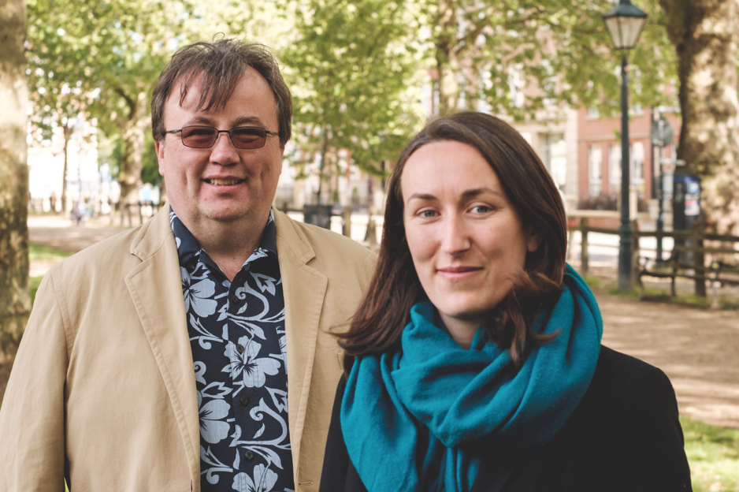 | Councillor corner  Lockleaze Councillors Heather Mack and David Wilcox were available to speak with residents. They chatted about new developments and existing community connections - how to connect new and existing communities. Road safety and road surfaces, particuarly concrete roads and joins/gaps in roads which were dangers to cyclists and Voi scooters.
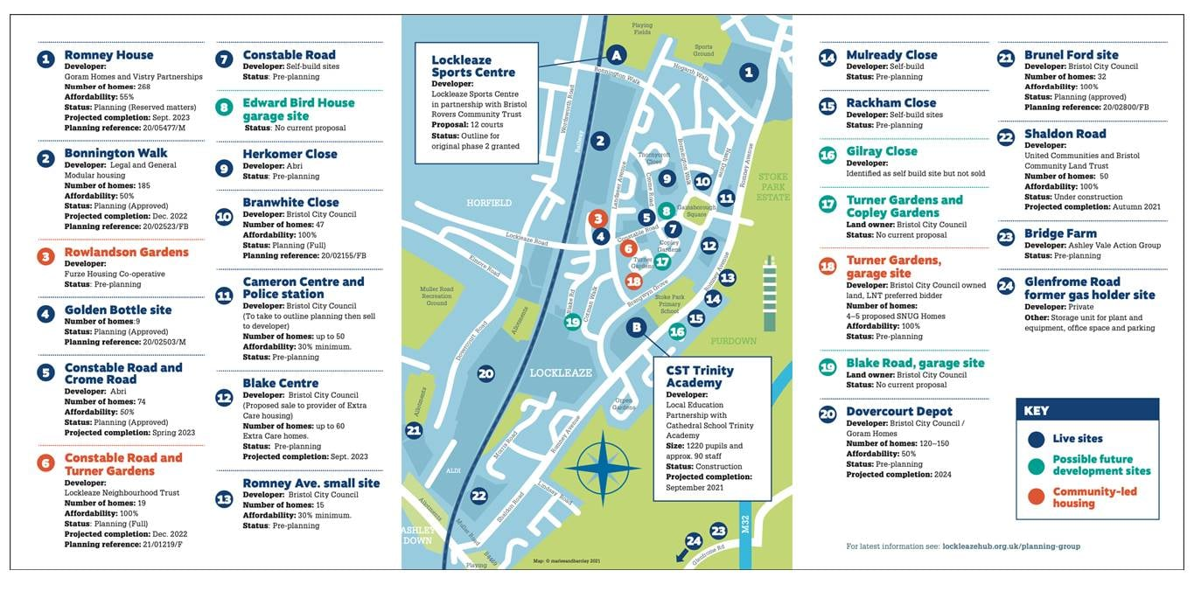 | Developments in Lockleaze  Number of new developments in the area. Discussions about associated infrastructure needed to support developments, traffic calming measures, need for more/better transport infrastructure - some happened and some in progress (e.g near Trinity School)
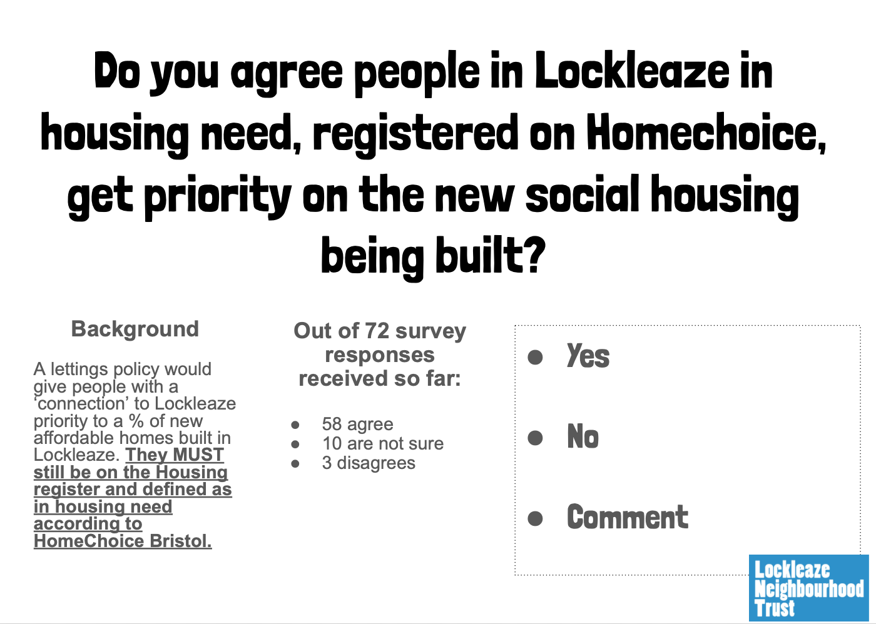 | Local Lettings Policy  Paul Sylvester from Bristol City Council discussed work to date with Lockleaze Neighbourhood Trust and residents developing a Local Lettings Policy to be an addition to housing allocation policy. Lockleaze and Lawrence Weston have been developing local lettings policy and these are informing BCC policy and will be used potentially elsewhere in the city. Lockleaze Local Lettings Policy had survey over 80 responses, focus group and discussion, now at final drafting stages - this was testing latest decisions on policy. Very subjective, different views about what makes local (6months, 2 years, 5 years. Policy progress very good, well thought out now finessing detail. Will have a major impact for local people in housing need given the development happening locally, keen to roll out across the City. Reminder it is just social housing but looking at how to give preference for shared ownership through early access to sale and pre-sale support work to help local residents interested and eligible for shared ownership opportunity of first-mover advantage. Now trying to get consensus on the policy but recognise emotive topic and not everyone is going to agree. Next steps - further consultation (?) and formalise (?) details for BCC to confirm.

