

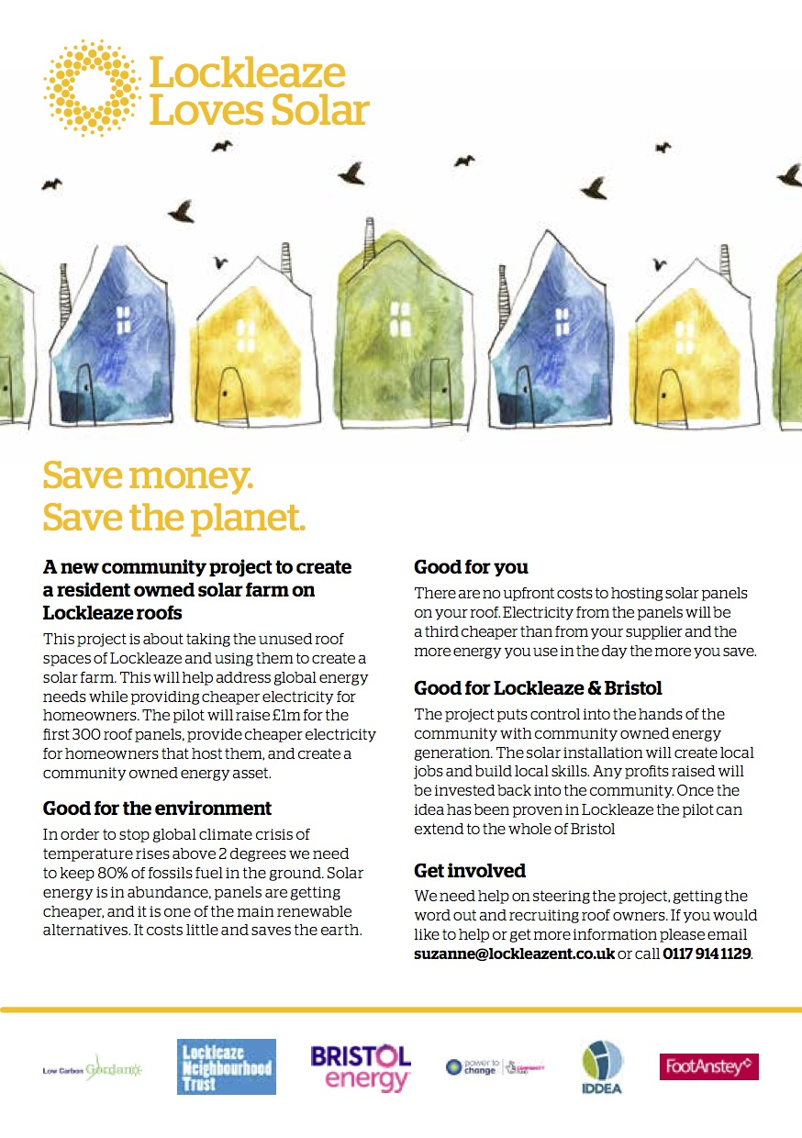

**Next Generation Energy**

Version 2 Learning Report

**Lockleaze Loves Solar – version 2 Learning Report**

## Contents

Contents 1

Introduction 2

What we did and the issues we encountered 3

Summary of Key Learnings 5

Conclusion 7

Appendix 8

## Introduction

This document is the sequel to the Lockleaze Loves Solar Interim Learning Report submitted to the Next Generation Energy scheme in the autumn of 2020. Within it we shall explain the pivot to version 2 (v2) of our model and the subsequent lessons learnt during that process.

As a brief reminder, version 1 (v1) of Lockleaze Loves Solar was to be a 1MW urban rooftop solar farm, a virtual power plant with free solar panels installed on the roofs of 300 homes in Lockleaze. The electricity they produce would be sold to the households at a discount and any surplus energy would be sold to an energy company on an export arrangement – or, if possible, shared with neighbours, also at a discount.

Whilst the arrival of the SARS-CoV-2 pandemic didn’t help matters, v1 was ultimately deemed unworkable in the current circumstances. The three prime issues, in no particular order, being:

1. the sale of Bristol Energy (and the absence of any other energy company able to step into their role as billing and customer account manager)
2. the low export price, compared with limited ways of increasing customer self-use above about 30%
3. the financial model which, once administrative costs and mandatory fiduciary responsibilities were accounted for, was not yet viable.

Three thresholds were identified which would need to be met (certainly one of the three, probably two and ideally all three if any scheme were to be financially self-sustaining) before v1 might be viable in the real world. These were:

1. domestic rooftop Solar PV installation costs (including all scaffolding and other labour/management/admin charges) of £500/kw or less
2. annually averaged domestic self-use of greater than 40%
3. a 25-year guaranteed electricity export rate of greater than 6p/kwh

For context, current installation costs are in the order of £700/kw, self-use (without batteries) seems to top out at about 30% and there are no 25-year guaranteed export rates.

Ultimately, the decision was made in July 2020 to try and pivot to an alternative model; one that should still result in an increase in the installation of domestic solar PV in Lockleaze, but funded by the householders themselves and lacking any of the business model or energy sharing potential of version 1.

## What we did and the issues we encountered

#### V2 in a nutshell

Lockleaze Loves Solar v2 was intended to be a signposting service that would connect householders who wanted to install domestic solar PV (and batteries) with a source of low-cost funding and an installer who could offer best-value installations. As part of the monthly repayments on the loan, a small sum would voluntarily be added (approx. £20 per installation per year) which would go to LLS in order to provide ongoing funding for additional signup campaigns.

#### Funding

In July 2020 we began discussions with Bristol Credit Union (BCU) about their potential as the source of our funding. BCU had previously explored solar funding loans but had not seen much uptake of them – possibly because of the interest rates being charged (in the order of 5%). After some discussion, a preliminary proposal of a £100k ring-fenced fund which would be available at circa 3% p.a. interest was put forward. Whilst this was a smaller pot than we had hoped for, since this would only fund about 20 installations (if batteries were included) rather than the 300 installations that we had originally envisaged, it still gave us something to work with and build upon.

We also began discussions around how we could build on this in the future, including concepts such as a philanthropic savings account where socially conscious and affluent citizens could put their money, to be paid little or no interest, but which would enable a large pot of money for householders to borrow from for their solar installations, thus enabling a larger number of installations.

However, regardless of the source of the capital, this loan-based funding model had one major drawback – it required that LLS act as credit Brokers on behalf of BCU. This will be explored further in the *Legals* section

Furthermore, it transpired that the £20 per annum surcharge could not be mandatory, only voluntary, which removed any form of income stability for the community organisation.

**Lesson: In a post-FiT landscape, you currently need to be able to access zero- or near zero-cost capital to make domestic PV work on a medium-term financial timescale.**

**Lesson: Without no-strings grant funding to drive the installations, financially precarious households will find it extremely difficult to adopt domestic PV without further straining their budgets for 10+ years after installation.**

**For further details see the table in the Appendix.**

#### Legals

Whilst v2 removed the need for roof leases, or all of the associated costs that a fiscally responsible community-funded business is subject to, it did introduce a few new regulatory and legal constraints. The key one being that, by signposting potential PV-owning households to Bristol Credit Union, we were in fact deemed to be credit broking on their behalf. This was not a showstopper, as it only required a relatively minor regulatory change on BCU’s behalf and then a signed agreement between LLS and BCU regarding the nature of the work that would be undertaken.

However, the regulatory changes proved harder to achieve than initially expected. FCA approval lead-times are currently estimated at 6 months from submission. This *may* be partly due to the impact of SARS-CoV-2 and so, in time, those lead-times may return to their previously level of 3 months.

Additionally, whilst LLS no longer needed to take out a lease on the residential roof-space, the scheme participants still needed to own their property in order to be able to conduct the installation, meaning that this scheme would still only really be available to owner-occupiers and extremely progressive landlords and would therefore be likely to exclude (by default) the vast majority of those in fuel poverty that this project was originally intended to help.

**Lesson: When you are dealing with multiple parties with various financial interests then *everything* requires a contract and this adds time, complexity and/or cost.**

**Lesson: Never underestimate the time impact of regulatory bureaucracy.**

#### Installation

After our original installer became unavailable, we reached out through our various networks which led to some preliminary conversation that seemed extremely attractive. Through different channels we were variously informed of sources of wholesale PV and battery infrastructure along with available installers with low-cost scaffolding solutions. Taking these values at face cost, it seemed as though we had identified a way of cutting significant sums off the cost to install a domestic PV system.

However, when a sample quotation for a model property was requested, it became clear that the previously quoted prices had not accounted for the ancillary costs of operating a business and thus the previously avoided margin of circa 25% reappeared, breaking the financial model once again. Because of the installation charges and the interest payments it cost more per month, over the 10-year lifespan of the loan, than the savings that would be achieved by the domestic PV installation. This meant that anyone already in fuel poverty would be worse off, in the short to medium term, by taking this deal than they would be if they did nothing. Given the aims of the scheme, this was a disappointing blow which further excluded those that it had been intended to help.

**Lesson: When buying a turnkey service from a 3rd party, the final sum is often far greater than the values of the obvious parts.**

## Summary of Key Learnings

*The points below summarise key learnings from v2 of Lockleaze Loves Solar, though many of them have echoes carried over from v1.*

**Understand the non-negotiable costs.** There is an administrative and compliance cost burden which comes from running a business rather than doing something yourself. This can range from legal and incorporation costs to insurance, maintenance and staffing. You need to fully understand how much you will need to spend on this (and how much any 3rd parties that you hire also need to spend on theirs) and factor it into the business model otherwise you will suddenly discover that the costs are far higher than initially assumed and there is no way to increase the revenue to cover them.

To give an example:

If I, using my own money, hire a company to install solar panels on my roof then currently my investment will pay for itself in about 10 years and if the system breaks then only I lose out.

If I have to borrow money to pay for the installation, the payback increases to about 13 years and if the system breaks then I still have to pay the loan, otherwise the loan company loses out.

If I am running a company which raises money from the community to then pay for another company to do the installations then the payback increases to over 20 years, and I have a fiduciary duty of care to my investors to ensure that the assets that their investment has bought are appropriately insured and maintained so as to minimize any risk of loss.

You cannot assume that someone will always be available to do the work voluntarily and so *must* base your business model on the assumption that you need to pay *someone* to do the work (customer management, billing etc.). In version 1, this cost was rolled into the energy supplier tariffs, whereas in version 2 it needs to be explicitly accounted for.

**Model, Test and Adjust**. Our feasibility study started with a spreadsheet model that showed the variabilities and dependencies and allowed us to model scenarios and test assumptions. This has continued to be important in decision making – e.g. on the need to ‘pivot’. However, it is important to ensure that you have people looking for both the positives and the negatives within such a model – it is very easy to make a spreadsheet provide you with the answer that you want, whether intentionally or by accident, and so external review by colleagues at regular stages is key to avoiding a form of enthusiastic groupthink around the viability of any proposal.

**Marginal Business Model**. So soon after the end of subsidies, any model was bound to be marginal. Wishful thinking does not improve it, and there is a continual need for a hard and dispassionate realism about what a business *requires* to be viable in the long term. Assumptions need to be questioned regularly, and projections tweaked accordingly. However, a marginal business model that has planned and prepared for all eventualities and worst-case scenarios is **still** a viable model (albeit as a non-profit in the very truest sense of the word) and it is important not to give up hope is your accounting seems to be an on-going zero-sum game. If that’s because you have rigorously analysed, and accounted for, your costs and risks then that’s fine.

**Agile Planning**. Things keep changing, and we have not been able to stick perfectly to our initial plan. It becomes necessary to hold the final end-goal in mind whilst rapidly adapting to and compensating for unforeseen events and new information. However, this type of project management is best suited for proximate and highly responsive teams, whose members can drop everything to swarm a problem and solve it. It isn’t so functional in a world of email and scheduling mutually available times for zoom calls, because an epidemic has stopped us from being able to work shoulder to shoulder for extended periods of time.

**The Perfect is the Enemy of the Good**. The pivot strategy eliminated some costs and legislative burdens and, given time, would have helped drive the uptake of domestic PV amongst a relatively small number of customers. However, it also meant that we were far less able to help those in fuel poverty. If, at the very beginning, we had agreed that it was acceptable to achieve one or more of several intersecting goals, rather than committing ourselves to achieving all of them (or none) then it might have been easier to agree on small incremental improvements that built toward the overall goal, rather than trying to solve a single large, complex and knotty problem.

## Conclusion

It would be all too easy to look at the challenges that we encountered and assume that community-funded domestic PV is a problem to be put into the “too-hard” pile.

However, as described in the introduction, we have identified trigger points at which this sort of project *could* become viable and they are not too far from the current reality. Better value batteries would significantly improve the self-use ratios, panel prices are still falling and there are innovative energy companies looking at pilot schemes for energy sharing that would raise the value of exported energy. On top of that, any increase in electricity prices would serve to further improve the appeal and financial return of local electricity generation via domestic PV.

We anticipate that other community organisations will be able to take this foundational work and build upon it, taking advantage of the expected improvements in costs over time and as strong a level of community engagement as was seen in Lockleaze, so that versions 3 and beyond of this model will, hopefully, prove to be successful.

## Appendix

“Model household” financial model for 3% loan funded domestic solar PV



Average annual additional cost to household over first 13 years = £118

Additional annual income to household from halfway through year 13 = £361, increasing with inflation thereafter